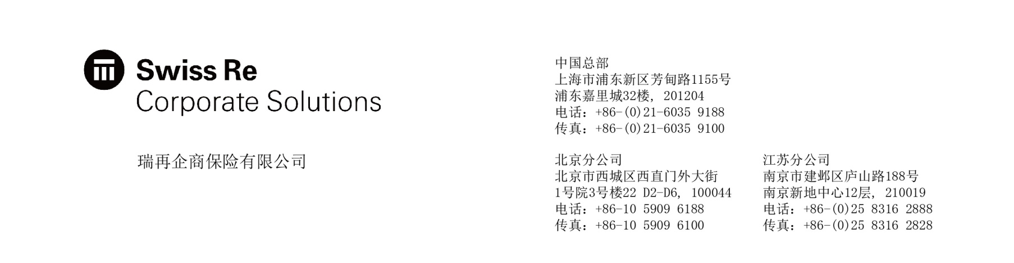

PERSONAL ACCIDENT INSURANCE CLAIM FORM

人身意外伤害险索赔申请表

Policy No. 保单号码：_________________________ Expiry Date 保单有效期至：YYYY/ MM / DD

Insurance plan 保险计划: □

Particulars of the Insured and the Claimant 被保险人和索赔人资料
Name of Insured 被保险人姓名：_______________________

ID No. or Passport No 身份证或护照号码：__________________________

Corresponding Address 通讯地址：________________________________________________________

Daytime Tel 日间联络电话：___________________________ Fax 传真：_____________________

Name of Claimant 索赔人姓名：________________________

ID No. or Passport No身份证号码：_____________________

email address 电子邮箱：_____________________

Corresponding Address 通讯地址：________________________________________________________

Daytime Tel 日间联络电话：___________________________ Fax 传真：_____________________

Relationship to Insured Person索赔人与被保险人关系：_________________________________

Date of Accident 出险日期：YYYY/ MM / DD
Have you applied for claims in another insurance company for this event/accident? If “Yes”, please specify. 就此事件/意外，你有否向其他保险公司索赔？如“有”者，请列明有关详情。
Please indicate your current status  请指出你现在的情况 | Fully recovered from this injury 完全康复/ Still under treatment 治疗中  Please delete the inappropriate one (请删除不适用者)

Please put a in the appropriate box of your claim below. Please list items & indicate the amount of your claim in detail.
(If there is insufficient space on the claim form, please specify the details on a separate sheet clearly and indicate which section the information relates to.)
请在格内用选择索偿之项目及详细列出索偿之内容及数目。（如空位不足，请另附纸张填写，并列明所述的项目名称。）

□ Accidental Death 意外死亡
The death results from 死亡是因为 □Public Conveyance Accident 公共交通工具意外 □Others 其他
Date, Time, Location and Circumstances of the Accident 日期、时间、地点及事件发生的经过：

Documents Attached 附加文件
□ Medical Report 医疗报告 □ Police Report 警方报告 (Case No. 档案编号 _______________________)
□ Death Certificate 死亡证明 □ Others (Please specify) 其他（请注明） ___________________________
□ Permanent Total Disablement or Permanent Partial Disablement 永久性全部或部分残疾
The death results from 死亡是因为 □Public Conveyance Accident 公共交通工具意外 □Others 其他
Circumstances of Accident 意外情况 |  | Description of Injury 受伤情况
Documents Attached 附加文件
□ Medical Report 医疗报告 □ Police Report 警方报告 (Case No. 档案编号 _______________________)
□ Consent Letter for Medical Record 索取医疗报告的授权信
□ The Appraisal Letter of Disablement Rate 伤残等级鉴定书
□ Others (Please specify) 其他（请注明） _______________________________________________________________________________
□ Accident Medical Reimbursement 意外医疗费用补偿
Circumstances of Accident 意外情况 | Description of Injury 受伤情况 |  | Currency/Claim Amount 索赔金额
Documents Attached 附加文件
□ Medical Report 医疗报告 □ Original Medical Receipt 医药费单据原件
□ Others (Please specify) 其他（请注明） _______________________________________________________________________________
Declarations 声明

I declare to the best of my knowledge and belief that the information given is ture in every respect. I agree that any concealment or incorrect statement in connection with this claim may result in prosecution and the policy shall become void. 本人谨此声明，根据本人所知，本索赔申请表上填报的资料均属事实。本人并同意，任何蓄意欺骗或隐瞒将构成法律责任并导致本保单失效。

Any persons from whom Sun Alliance Insurance (China) Ltd. have collected information as aforesaid, shall have the right of access to and to request collection of any personal information concerning themselves, and the purpose of using such personal data. I understand that a request for such access can be made to the Compliance Officer of Sun Alliance Insurance (China) Ltd. via, mail to 32nd Floor, Kerry Parkside No 1155 Fangdian Road, Shanghai, 201204, or Fax to (86 21) 6035 9103. 本人明白就提供上述资料给太阳联合保险（中国）有限公司“贵公司”之任何人，均可查询其资料用途、查阅及更改有关资料。本人可循下列途径向贵公司之条例事务部主任提出：邮寄致中国上海市芳甸路1155号嘉里城32楼，或传真致(86 21) 6035 9103.

Claimant’s Signature (18 yrs old & above) / Date Insured’s Signature (18 yrs old & above) / Date
索赔人签名（18周岁以上）/ 日期 被保险人签名（18周岁以上）/ 日期
如有任何理赔查询，请于星期一至星期五上午九时至下午五时半，致电理赔服务热线 800-820-5918.

